Autoencoders Damaged-Undamaged Classification Through Reconstruction Error
Train Parameters:
Epochs: 20
Batch_Size = 32
Window_Size= 30
Step_Size = 1
Used Datasets:
Ocak-Kasım 10 dk lık veriler.xlsm
Ocak-Kasım 10 dk lık sıcaklıklar 1.xlsm
Ocak-Kasım 10 dk lık sıcaklıklar 2.xlsm
--- Train Results ---
Threshold : 0.07952804
Train MAE mean: 0.02289944
Test (Damaged) MAE mean: 0.13743027Detected damaged windows (or time steps):
Detected damaged windows (or time steps):
window_index mae_loss threshold anomaly
0 0 0.098952 0.079528 True
1 1 0.098312 0.079528 True
2 2 0.098260 0.079528 True
3 3 0.098413 0.079528 True
4 4 0.097365 0.079528 True
5 5 0.096649 0.079528 True
6 6 0.095473 0.079528 True
7 7 0.094527 0.079528 True
4 4 0.097365 0.079528 True
5 5 0.096649 0.079528 True
6 6 0.095473 0.079528 True
7 7 0.094527 0.079528 True
4 4 0.097365 0.079528 True
5 5 0.096649 0.079528 True
4 4 0.097365 0.079528 True
5 5 0.096649 0.079528 True
5 5 0.096649 0.079528 True
6 6 0.095473 0.079528 True
7 7 0.094527 0.079528 True
8 8 0.094221 0.079528 True
9 9 0.093958 0.079528 True
...
[48003 rows x 4 columns]
--- Other Results ---
Accuracy: 0.9988 The rate of correct predictions.
Precision: 0.9994 The rate of how many predictions made on the damage are true.
Recall: 0.9992 Missing Value, the model points most damaged values as undamaged.
F1 Score: 0.9993 The F1 score is the mean of Precision and Recall.

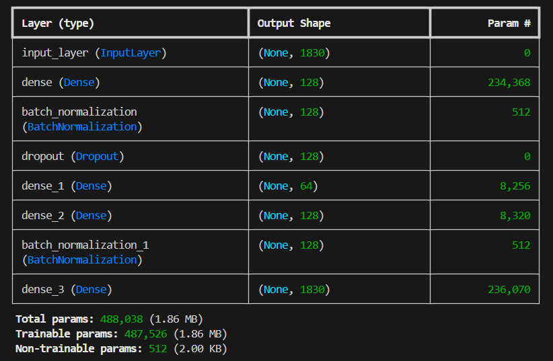

The Confusion Matrix:
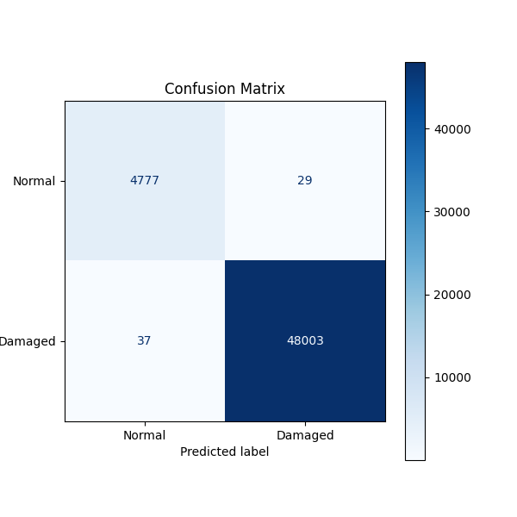
Validation and Loss Graphs:
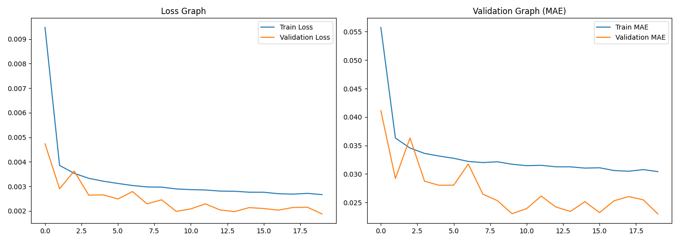
Others:
